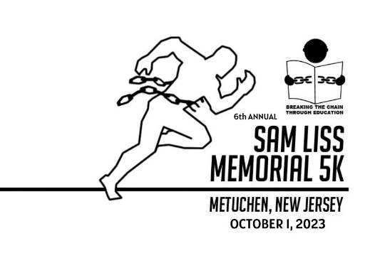
June 2023

Dear Merchant and Friend,
We are thrilled to announce plans for our 6th Annual Sam Liss Memorial 5K on Sunday, October 1, 2023 at a new location this year, Edgar Middle School in Metuchen!
Our story: BTCTE was founded by Metuchen High School teacher, Evan Robbins, with the help of a small group of students. One of the founding members, Sam Liss, a 2010 graduate of MHS, tragically passed away in 2017 from cancer at the age of 25. This annual 5K honors Sam’s life and raises money for a cause he cared deeply about. BTCTE is a 501 (c)(3) charitable organization dedicated to eradicating child slavery and to our children’s long-term success. We help our children achieve a bright future by offering a variety of educational opportunities (high school, college, vocational training, etc) and assisting them as they transition into adulthood. This event empowers local Metuchen students to become thoughtful citizens of the world.
Your sponsorship/donation will directly provide much-needed support to our children. Please consider becoming a sponsor at one of the levels below:

$100 Friend Sponsor – your name will be placed on BTCTE website’s sponsor list

$250 Supporter Sponsor – your name will appear on the back of the shirt and on BTCTE website’s sponsor list; you will receive 2 race shirts

$500 Contributor Sponsor – your name/small logo will appear on back of shirt and on BTCTE website’s sponsor list; you will receive 4 race shirts

$1,000 Partner Sponsor – your name/medium logo will appear on back of shirt and on BTCTE website’s sponsor list; you will receive 8 race shirts

$2,500 Title Sponsor – your name/large logo will appear on back of shirt and on BTCTE website’s sponsor list; you will receive up to 12 race shirts

$5,000 Platinum Title Sponsor –your name/XL logo will appear on back of shirt and on BTCTE website’s sponsor list; you will receive up to 20 race shirts

To become a sponsor, please go to this link www.btcte.org/5ksponsor23. Our website will link to our sponsors and be promoted heavily over the next few months while runners register for the race. Thank you in advance for your consideration and generosity. Stay healthy and safe!

Sincerely,

Carolyn Taylor,
Director of Development
Breaking the Chain Through Education
Ctaylor@btcte.org; 732.754.1905
www.btcte.org

