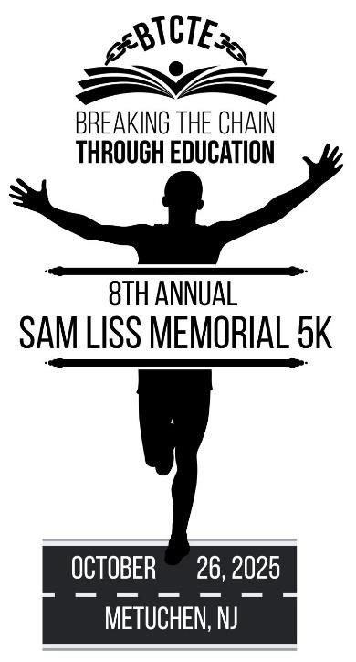

**8th Annual Sam Liss Memorial 5K Run/Walk**

Benefitting Breaking the Chain Through Education

**Sunday, October 26, 2025 at 9:00 AM**

**at Metuchen High School**

**Event Fee: $35 **Registrations received by Sept 30 are guaranteed race shirts.** $40 fee day of race.**

**Awards:** Race Awards will be presented to the top males and females based on age divisions

Complete the form below or register online (processing fee applies) at btcte.org

Email:



Phone:



|  |  |  |  |  |
| --- | --- | --- | --- | --- |
| **Participant** | **Sex** | **Date of Birth** | **Age on race day** | **T-Shirt Size (S, M, L, XL, XXL or YS, YM, YL, YXL)** |
|  |  |  |  |  |
|  |  |  |  |  |
|  |  |  |  |  |
|  |  |  |  |  |

Registration Fee: $35 …………………………….....……………………... $ Can’t join us, want to donate? …………………………………………. $ **Grand Total**……………………………………………………………... $

Make checks payable to Breaking the Chain Through Education Send checks and form to 38 Marion Road, Verona, NJ 07044

Breaking the Chain is a non-profit 501(c)(3) organization benefiting trafficked children in Ghana.

Waiver: In consideration of the acceptance of this entry, I hereby for myself, heirs, executors, and administrators, waive and release any and all rights and claims for damages I may have against Breaking the Chain Through Education, its organizers, the Borough of Metuchen, the State of New Jersey, and the sponsors, race officials, and volunteers associated with this event for any injury that may occur as a result of my participation in this event.

Additionally, the Organization may use your email to communicate to you about this and future events.

Participant signature or Parent/Guardian: